+-+-+-+-+-+-+-+-+-+-+-+-+-+-+-+-+-+-+-+-+-+-+-+-+-+-+-+-+-+-+-+-+-+-+-+-+
Mansoor Zafar
100503226
mzafar15@myseneca.ca

+-+-+-+-+-+-+-+-+-+-+-+-+-+-+-+-+-+-+-+-+-+-+-+-+-+-+-+-+-+-+-+-+-+-+-+-+
Table of Contents:
- Part A (Blackboard interface Analysis, Nielsen’s Heuristic)
[Pages 1 - 5]
  - Page
  - Heuristics analysis
- Part B (Re-design)
[Pages 5 - 9]
  - Designs
  - Annotations
  - Re-cap on fixing problematic heuristics

+-+-+-+-+-+-+-+-+-+-+-+-+-+-+-+-+-+-+-+-+-+-+-+-+-+-+-+-+-+-+-+-+-+-+-+-+
Part A
Page: Institution Page
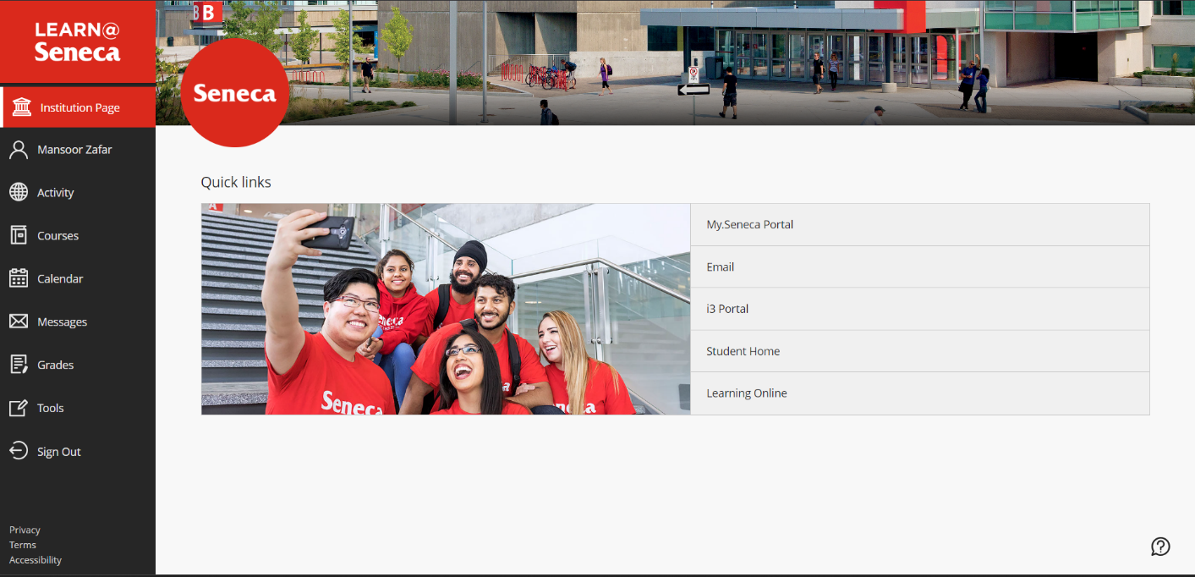
Help and Documentation
This is a principal that this interface does half correct. At the bottom right corner, there is a help button that can help users who need some sort of help.

However, this only gives documentation for blackboard itself and not a way to search for help with Seneca.
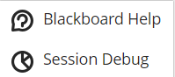
This is why it half helps, if the user needs some sort of guidance or help with blackboard, it has an easy to find and access help page that is clear to understand.
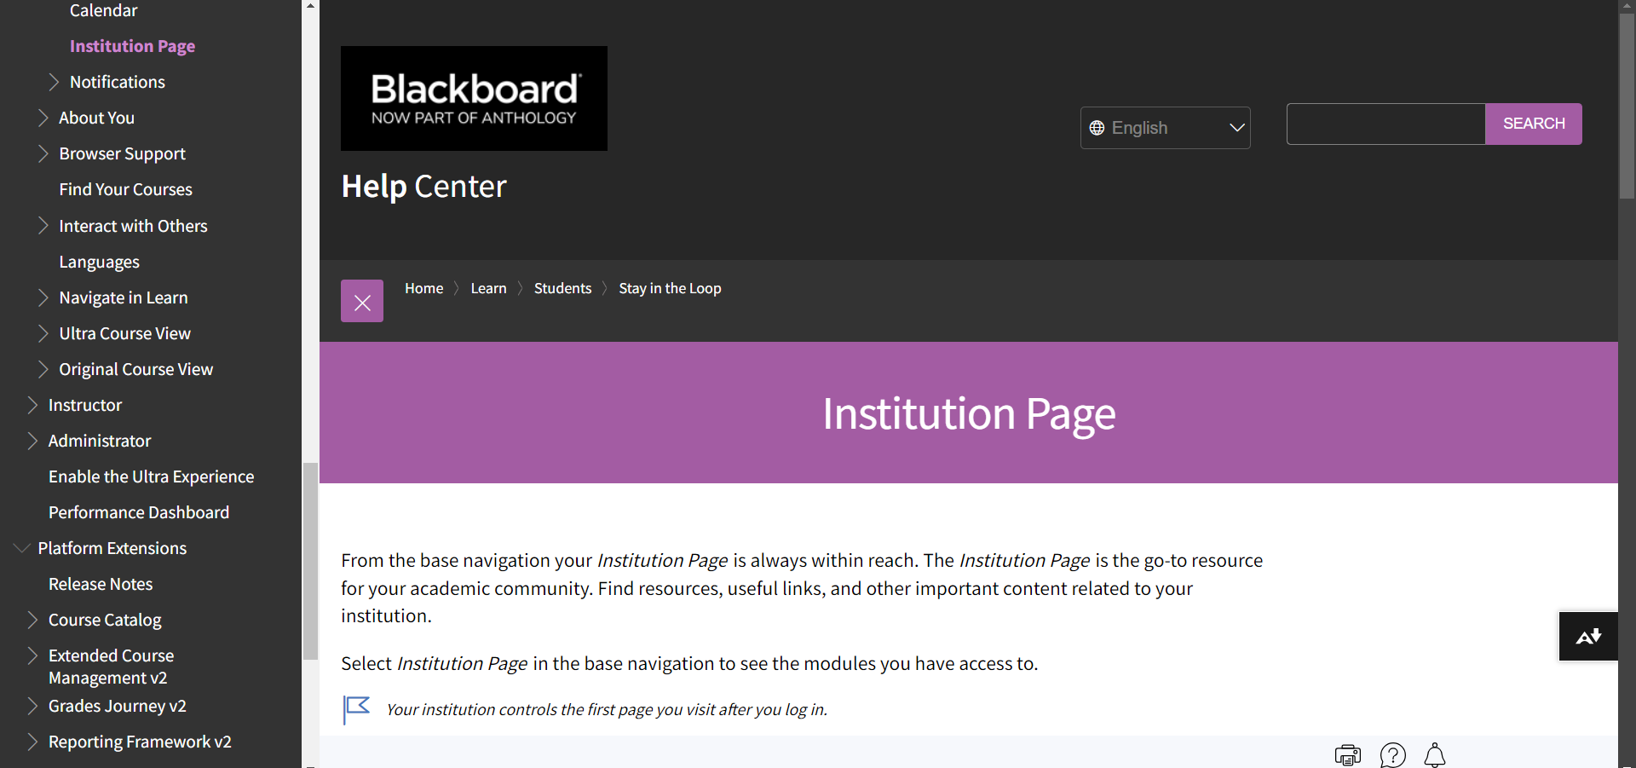
However, if the user needs some help with Seneca, the actual institution, then they have no clear way of searching for help or even a clear help button related with their institution.

Aesthetics and Minimalist Design
This interface passes this as, it does not contain any information that isn’t relevant to the design as it only contains links and minimal pictures that all pertain to the page. The use of the whitespace is proof of this.
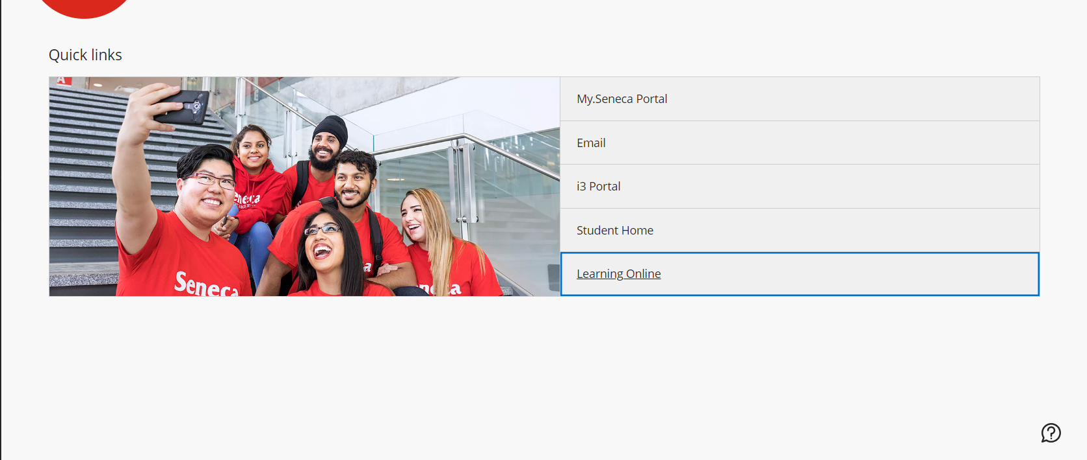
A lot of the space is whitespace as this design only added what they needed and left the as whitespace. There is no extra dialogue that takes away from the value as its very minimal content and concise.

Flexibility and Efficiency of Use
This interface fails this heuristic as it doesn’t really provide a way for advanced users to quickly make their way around the application. Rather, it makes the experience for all the users equal, however, this heuristic emphasizes that more advanced/experienced users should be able to navigate around the site faster through shortcuts i.e added a combination of key binds that directly go to the link rather than needing to press it with a mouse each time.

Recognition rather than Recall
This interface half fails this, as the sidebar on the right is available of most of the interfaces however, it fails in the regard of the quick links.

The quick links have no icon, widget or any other way to access them on this site, they can only be remembered by recall as they have no identifier other than the words.

Consistency and Standards
This interface half succeeds, the menu bar on the right is all consistent and is what as you’d expect.
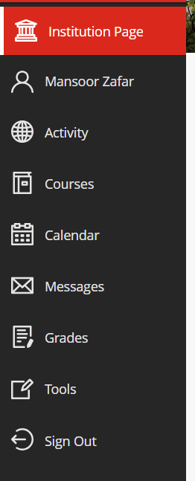
However, the quick links:
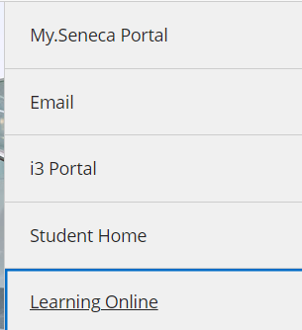
This interface succeeds in having some of the items be consistent and clear ex. Email, student home, learning online however, the i3 Portal and My.Seneca Portal is the confusing factor. They both contain the name portal and may cause some confusion, especially since the name i3 is very ambiguous and unclear.

User Control and Freedom
This interface fails this heuristic as when clicking on any of the quick links, it opens a new page and sends you to that page, however, if the user mis-clicked the link, now they would have opened an extra page without wanting to. They would now go through the hassle of closing the page, going back and returning to their previous want. If they had a confirmation saying something like, “This link is sending you to page X, confirm?” then it would pass. But right now, it just sends you directly to the new linked page.

Match Between System and Real time World
This interface half passes this heuristic as the navigation bar’s icons all are normal conventions for their respective content. I.e, the profile option has a profile icon, the sign out has a leaving icon, the messages icon has a mail icon and so on. Furthermore, the red highlight of the current page and no highlight of inactive pages also matches real conventions.

However, as I mentioned before, the quick links have no such association. They just say the links purpose but have no associating icon and thus have no way for the user to match the link with any sort of content without needing to read the name. However, the naming convention mostly passes as everything expect “i3 Portal” passes normal naming conventions as they are all clear and easy to understand.

+-+-+-+-+-+-+-+-+-+-+-+-+-+-+-+-+-+-+-+-+-+-+-+-+-+-+-+-+-+-+-+-+-+-+-+-+
Part B
- Designs
Home Page
(ON NEXT PAGE)
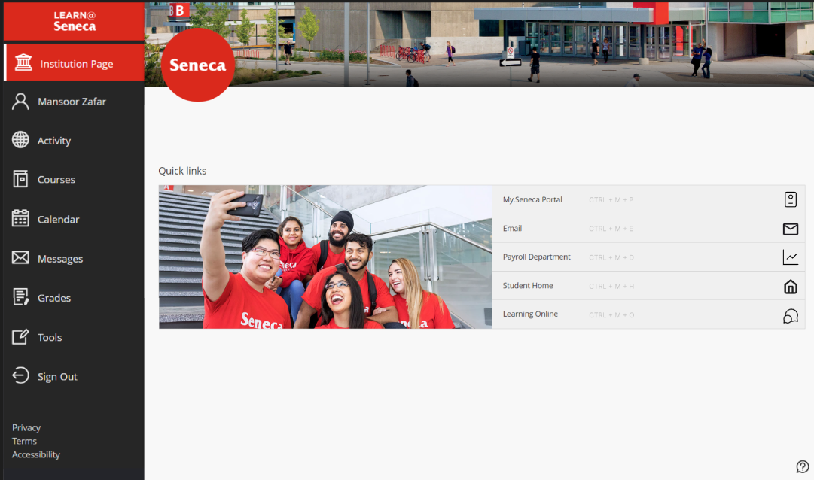
Link Confirmation Popup
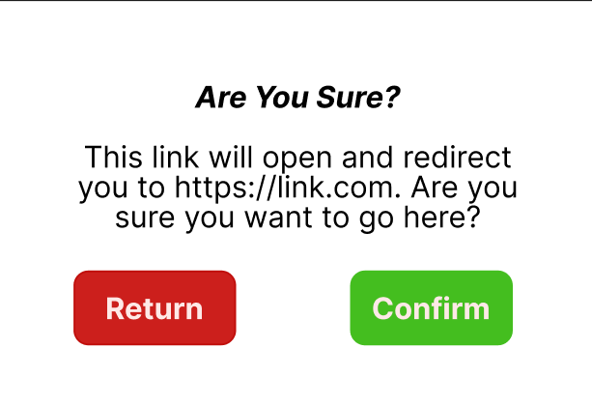
Help Popup
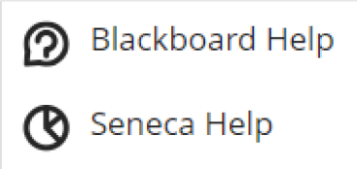

- Annotations
Item: Quick Links
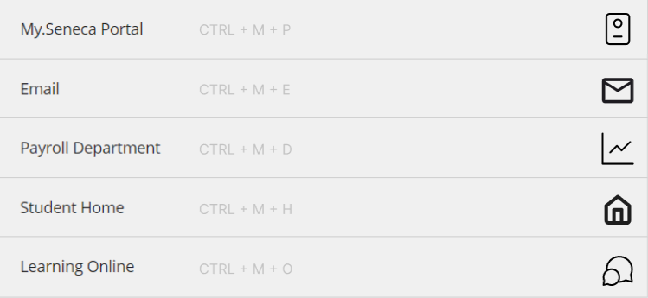
Firstly, I changed the name of the “i3 portal” to what it is, the “Payroll Department”. Then I added some transparent but visible key-based shortcuts that an experienced user would know and could thus use to more easily navigate through the links without the need for manually moving their mouse and clicking on each individual link. Afterwords, I added icons next to each item, this is to add association with each link. Each link has an icon that best represents that actual associating content alongside it.

Clicking on a link:
When the user clicks on a link a confirmation popup will appear as so.

This confirmation page allows the user to either select return to go back to the main page, or they can press confirm to actually open and redirect to the desired link.

Item: Quick Help

When the user selects this option, I removed the “Session Debug” option and replaced it with a more helpful help option. When clicked, the user will be presented with this popup:

Now, if they need to find help regarding blackboard, they can still do so and if they need help with Seneca’s content, they can click this which will redirect them to the Seneca help page: (https://theservicehub.senecapolytechnic.ca/s/).

Recap on fixing the problematic heuristics:
- Match between System and Real World
  - Added icons that appropriately associate to the quick access links
  - changed the “i3 Portal” to the more accurate name of “Payroll Department”,
    - Source for that (https://employees.senecapolytechnic.ca/spaces/join-space?spacetojoin=mSgtlXXEYyxgrA0uSwBs1Q%3D%3D&ReturnUrl=/spaces/20/payroll/articles/news/13165/changes-to-first-pay-of-thursday-jan-6-2022#:~:text=Seneca's%20online%20payroll%20system%20is,payment%20information%20and%20annual%20records.)
    - 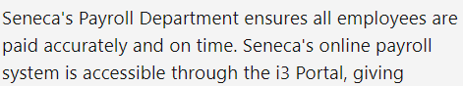

- User Control and Freedom
  - Allowed the user to back out of clicking on a link if they so desire to rather than forcing them to have to go through the extensive process of dealing with an unwanted link opened through this popup
    - 
- Consistency and Standards
  - As mentioned earlier, fixed the weird name of “i3 portal” to a more standardized and normal convention

- Recognition rather than Recall
  - By adding the icons to the quick links, they can be more easily recognized without the need for reading the names

- Flexibility and Efficiency usage
  - Added key binds to allow more advanced users to be able to simply use a shortcut to access those links rather than needing to manually click it every time.

- Help and Documentation
  - Changed the help options presented by the help button at the bottom right corner
    - 
  - Allowed for both accessing help on Blackboard and Seneca the institution itself
    - 

